**DESIGNING SEATBELTS TO INCREASE SAFETY AND ANALYZING USE OF THE DESIGN BY CUSTOMERS USING GAME THEORY**

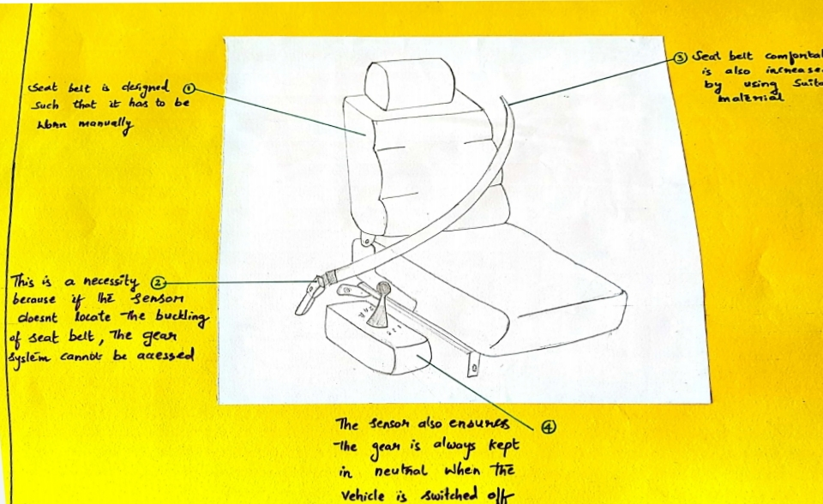

Our system is automatic seatbelts for vehicles. This does not mean that the seatbelt is automatic though. We made sure that the vehicle does not move unless the seatbelt is worn manually. We came to the topic because of the accidents caused by 4-wheel vehicles. We wanted to increase safety of travelling through cars (behavior the system).

System: seatbelt which connects gear via sensors

Components: It comprises of leather seatbelt, sensors, connections, sash shoulder, seatbelt tongue, bolts, nuts, buckle, retractor, pillar loops

Functions:

* There are sensors in the tongue of the seatbelt, also in the buckle. The sensor in the buckle senses the latch, which then send signal to the hydraulics.
* The gear system is controlled by fixing a hook/constraint on the hydraulics which controls the diaphragm movement.
* Once the diaphragm moves, the clutch can be changed hence freeing the gear system.
* Hence the gear cannot be changed unless we wear the seatbelt. Sensor used is Infrared Rays (IR). Rest of the part are similar to the old seatbelt system.
* Seatbelt is made from a material which increases comfort.
* Sensors are also placed to check whether the vehicle is moving or not. If its moving, then the seatbelts will be locked and cannot be removed (unless there is some emergency).

The structure is as shown above. It is not much different from the previous seatbelt system. We have decided to increase comfort of wearing the seatbelt by using appropriate material.

Aggregate level of intelligence

Intelligent item (component level):

* + - Sensor uses signals to connect to the lock in the gear which decides the movement of the vehicle. We can reason that each component has its own tasks and they see to it done properly.
    - The seatbelt is made using knowledge of previous system. So, it is already verified that components work in harmony.
    - Hence, each component is intelligent as it takes care of its tasks.

Intelligent container (product level):

* + - The whole system can take care of all the functions once we properly input locks on the hydraulic system which connect gear to wheels and take care of the sensors.
    - Since all components are non-living, we can assume that the system functions properly until there is some fault in the components (hardware).

Level of intelligence

Information handling (passive):

* + - The seatbelt tongue is inserted into the buckle.
    - hydraulic system releases hook on the diaphragm.

Problem notification (active):

* + - The sensors sense the tongue inserted into the buckle and gives signal to the hydraulics.
    - Signal is received by the hydraulics and it releases the constraint/hook on the diaphragm.
    - Once the diaphragm is free, we can change the gear as the clutch is free.

Decision making (intelligence):

* Once the system is sure that the user is buckled up, it then releases the lock in the hydraulics and allows the vehicle to move.

Location of intelligence

Intelligence at object (embodied):

* Sensor senses the latch and gives signal to unlock the hydraulics (the sensor is coded to release lock when sensed). This whole process requires intelligence.

Intelligence in network (remote):

* The user is notified when he has not worn seatbelt and can also observe that he cannot change the gear. Similarly, he cannot remove the seatbelt while travelling. This itself shows that the system is intelligent as it communicates to the driver mentally.

Collective system comprises of small components whose interaction causes complexity in the system.

Some principles of collective system are self-organizing, exhibiting multiple stages of equilibrium and signals. Also, self-organizing is divided into aggregation, clustering and sorting, nest formation, foraging and division of labor.

In our system, the signals from the sensors and constraint on hydraulics play a crucial role in the systems success. The sensors individually cannot make a huge difference. But as a group it can even measure the speed of the car, whether the vehicle is moving. It continuously keeps a check on the speed so that the seatbelt cannot be removed. Only when the car stops, we can remove our seatbelts. This is because sensors keep communication with the sensors in the buckle thereby locking the latch during movement and unlocking when stopped. Sensors can also cause movement of vehicle. This is self-organizing. When the sensors get confirmation to release constraint in the hydraulics, this allows movement of vehicle.

What we don’t understand here is that to connect engine and the tire, we need a system of a flywheel (frictional material attached on both sides) on top of a rotating disc. On top of the flywheel we require the diaphragm and above that we need pressure disc.

There is a need for stopping the engine while we change the gear. But this is tedious and we do not go for this method. Hence, we use clutch which is connected to the diaphragm, the diaphragm expands and the gear can be moved without fear of stopping the engine. So, the diaphragm is a key factor for the movement of vehicle.

Our aim is to attach a constraint to the diaphragm, that is, apply constraint on the hydraulics. But this is only possible when the sensors provide information that the seatbelt has been worn, information which can only pass through signals and to unlock the constraint.

Hence the information received (via signals) decides the gear system and hence the movement of the vehicle.

Feedback Loops from System terminology suggests the existence of relational loops between components of the system that affect the system. They are classified as Positive Feedback loops and Negative Feedback loops.

* The positive feedback loop is defined as when there is a change in the loop then the complete loop works to magnify the change hence pushing the system away. One component follows the other component, this can be seen as a component receiving an instruction and this instruction is actually directing it to reach its goal in a better form/shape than the previous instruction thus the agent receiving this instruction does as directed readily.
* The negative feedback is defined as when there is a change in the loop then the loop works to diminish the change hence retaining the stability of the system. A component is driven back by the other component and thus resisting the change. Here we witness the intelligence of the loop, if the system is intelligent enough to resist the change or adjust the change, if the loop is intelligent enough then the change would reduce and the system would be less affected by the change.

Our system consists of more positive feedback loops than negative feedback loops as we aim for the betterment of the safety and comfortability through seatbelts.

**Metaphor:**

* System: seatbelt which connects gear via sensors
* Environment: the environment change occurring is the insertion of seatbelt tongue into the buckle.
* Information sources and sensors used: the system must have realized that the seatbelt was inserted into the buckle because the sensors send signals to the hydraulics to release the constraint on the gear thereby allowing movement of the vehicle.

1. Through signals, the system recognizes information of insertion.

Also, when in motion, other sensors sense the speed of the vehicle and locks the hydraulics accordingly.

* Functions driven by information are:
  + Signals send to the hydraulics.
  + Release of constraint on the diaphragm.
  + Signals from sensors which sense motion of vehicle.
  + Locking of seatbelt under motion.
  + Unlocking of seatbelt when vehicle is stopped.

This system is adapted from the behavior of dolphin escaping danger. Dolphins use an excess amount of defense mechanisms to defend themselves from danger. These include intelligence, speed, communication and echolocation. It recognizes danger using echolocation, the dolphin is able to sense predators and avoid that path. Similarly, our system senses whether the user is safe or not (detection of tongue in the buckle). Only then movement is guaranteed.

Positive feedback:

* Ensures safety unlike previous system (even though previous system also enforces safety, people can decide to wear or not. It is not like that here). This can be extended to the backseat seatbelts too.
* We increase the comfortability of seatbelts by using good material.
* Sensors used are readily available.
* It is economically feasible.
* Reduction in death.
* Sensors do not get damaged easily.
* Constraint does not get damaged easily.
* Sensors under the seat can sense person via body temperature.

Negative feedback:

* If the user just wants to park his car to another spot in the same location (the case where he does not have to accelerate beyond 20km/hr.) he is forced to wear seatbelts anyway.
* No comfortability no wearing.
* Maintenance of constraint in hydraulics is tough.
* Mentality of people who are used to not wearing seatbelts is not good.
* This idea cannot be implemented on pets.

Increase in comfortability by change in material.

+B

No comfortability

+B

+B

Maintenance of hydraulics.

+R

+R

+R

Mentality of people who do not like to wear seatbelts are not good.

Forced to wear for parking also.

Idea not implemented for pets.

Constraint not easily damaged.

Reduction in death

Economic feasibility of sensors

Readily available sensors

Safety ensured

Senses person in seat with body temp.

System(seatbelt)

Sensors not damaged easily.

This is the feedback loop generated.

It shows more positive feedback than negative feedback hence shows positive result.